**IFT 466 Advanced Computer Networks**

**Lab 26  
Host Standby Router Protocol (HSRP) – Going deep!**

After you complete each step, put a ‘√’ or ‘x’ in the completed box

**Note:** To complete this lab, you will need Packet tracer version 6.1 or higher

**Part 1: Setting up and configuring the topology**

1. We will use the Cisco Catalyst 2811 router
2. We will add the HWIC-2T module to the router and make 3 copies of the same router and rename each router as shown in the diagram

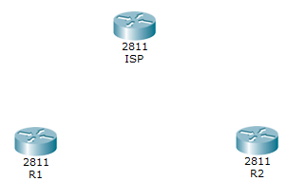



✓

1. Connect R1 and R2 to ISP via a serial connection (Serial DCE)

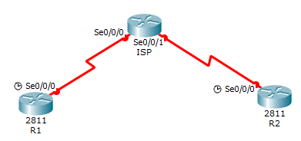

 ✓

1. Now add 2 switches, 2 PCs and 1 server to the topology. Connect the switches to the routers, PCs to the switches, the switch to the switch and the router the server which we will rename as a Web Server

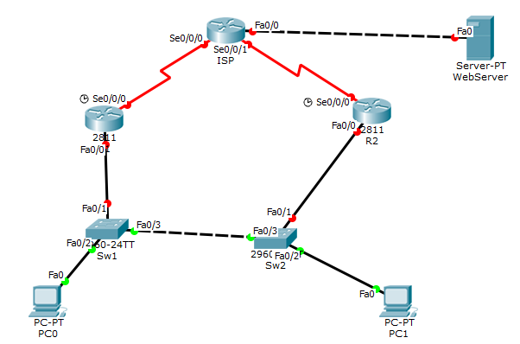



✓

1. We will now complete the addressing scheme for each device

* Assign IP’s to all routers and make sure you turn on the ports
* Enter the IP addresses, SM and DG’s into each PC
* Add the IP address 8.8.8.8/24 with a DG of 8.8.8.1 to the Web Server.

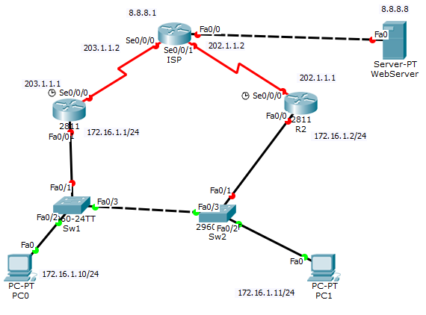

✓

**Before we proceed to Part 2, your topology should now look like the following image   
(all green connections)**

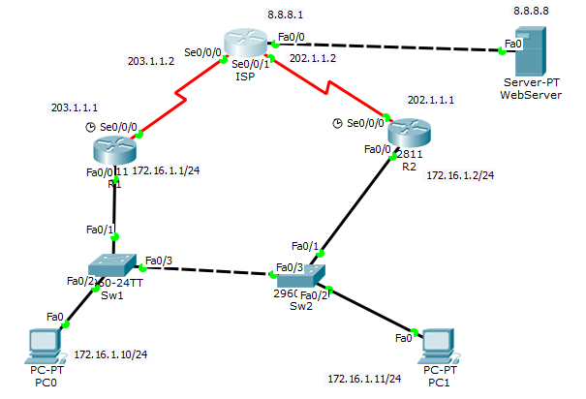



✓

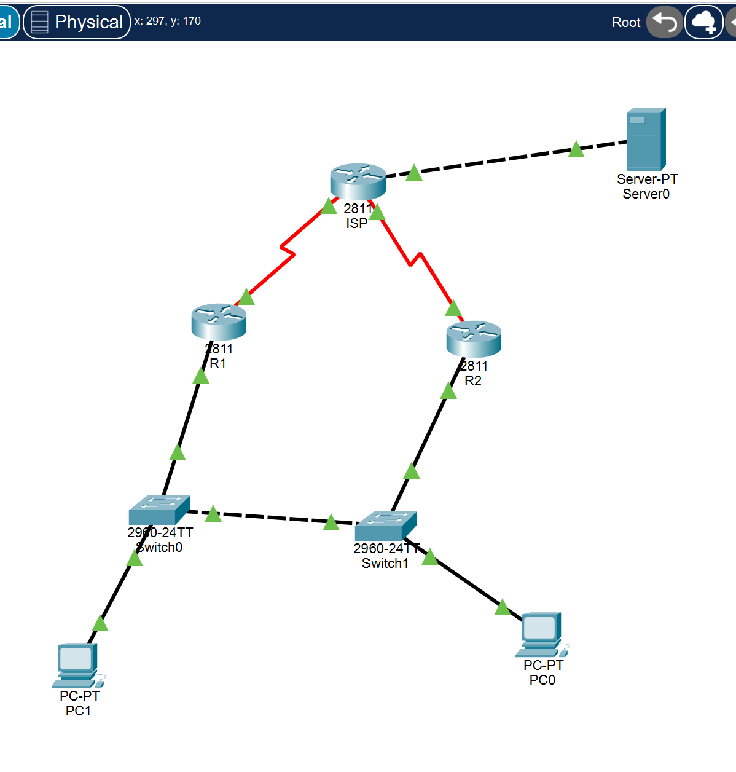

**Part 2: Configure HSRP on a router**

**Step 1**: Configure routing on all routers

1. Set the default route on each route

* On R1 – configure default route



* Repeat same default route procedure for R2



* On the ISP router we will configure a static IP to R1 and R2



✓

1. You should be able to ping the Web server (8.8.8.1) from either PC.

If not, check you configuration settings

 ✓

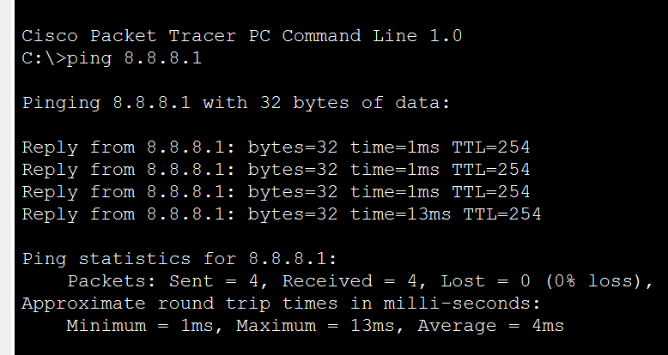

1. Now go into PC1 and run tracert and you should get the following to track the hops

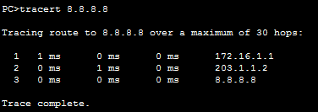

Repeat the same tracert command for PC 2



✓

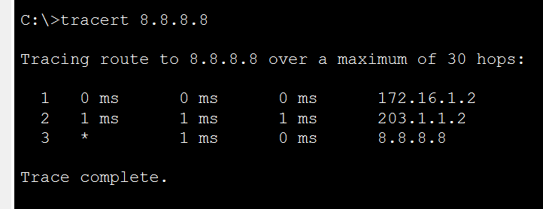

1. If we shutdown the default gateway port for PC 0 (turn of the Fa0/0 port on R1) then PC 0 will not be able to communicate with the web server.

We will start a continuous ping to the Web Server (8.8.8.8) from PC 0

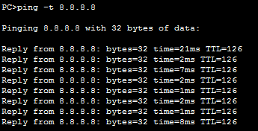

.



✓

1. We will the turn off the router Fa0/0 port (DG to the PC 0) and the ping suddenly times out so PC 0 can no longer access the internet or the web server (image on the right)

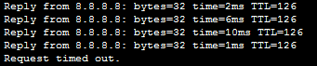

 ✓

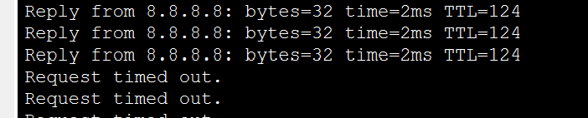

1. When we configure HSRP (we configure redundancy to the user and the network), so if the router goes down, as we just demonstrated, PC 0 will still be able to connect to the Web Server.



✓

**Step 2: Configure HSRP on R1 and R2**

We will Set R1 to Primary, Active and Priority 150 (outlined below)  
  
We will set R2 to Secondary/Backup, Standby and Priority 120 (outlined below)

We will set the Virtual IP = 172.16.1.254 (outlined below)

We will change the DG on PC 0 to the Virtual IP address (repeat for PC 1)  
(Perform this step now, as shown on the image on the right)

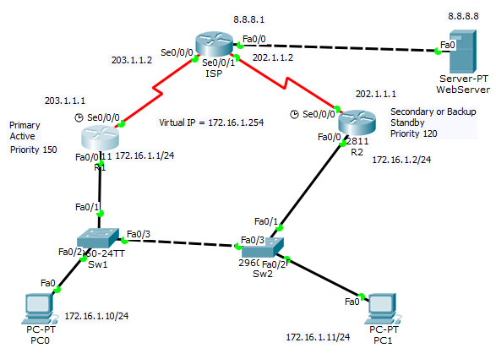

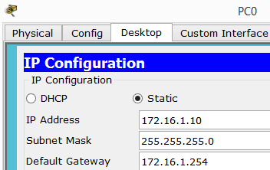

 ✓

1. Go to R1 and type the following command to enable HSRP

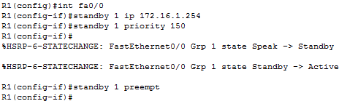

 ✓

1. We will now enable HSRP on R2 via the following command

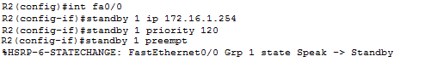

✓

1. Now check R1 for the updated standby configuration via the show standby brief command

R1 is in active state, correct priority (150), standby address is that of R2 (172.16.1.2) and the Virtual IP address is also set (172.16.1.254)

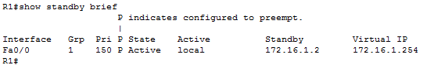

 ✓

1. Now check R2 for the updated standby configuration via the show standby brief command

R2 is in standby state, correct priority (120), active address is that of the primary router (R1 172.16.1.1)) and the Virtual IP address is also set (172.16.1.254)

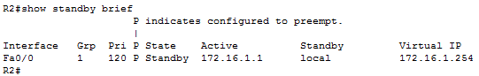



✓

**Step 4: Testing and disconnect interfaces on R1 and R2.**

1. On PC 0 and PC 1, ping the Web server as we did previously (we have a new DG on both PCs i.e. virtual IP address and also run the tracert command as we also did)…everything should be working ok and you can access the Web server.  
     
    ✓

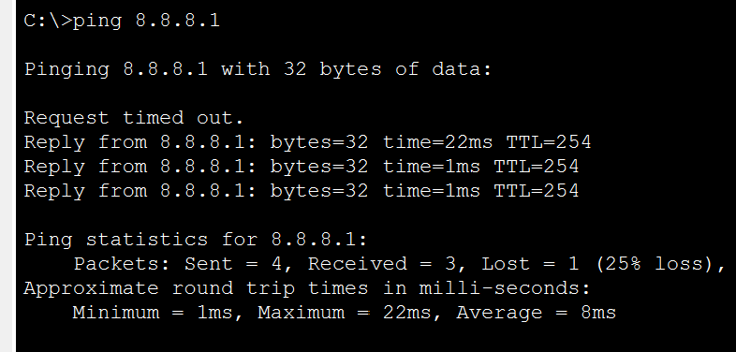

1. Did you notice the first hop on PC 1 is now Router 1 (172.16.1.1.1) and not Router 2 (172.16.1.2) as it did previously with tracert command. Traffic now runs across the switches and over to Router 1.

 ✓

1. We will now do a similar ping as before and then now shut down the interface Fa0/0 on R1. After a few seconds we start getting replies again and the user can still access the Internet/ Web Server

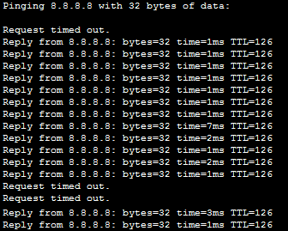

✓

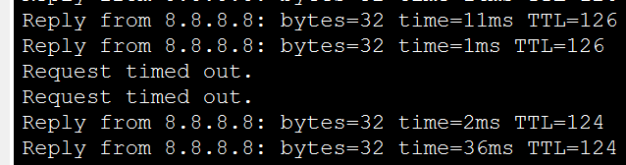

1. When you shutdown the interface on R1, check R2 and you see that its now in Active state





✓

1. Now run the show standby brief command on R2 and you see it is now active

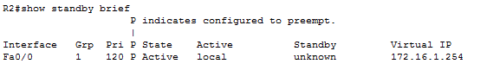



✓

1. Now turn the interface back on on R1 and see that R2 has changed back again







✓

1. Now we will shut down the interface on R2 and ping from PC 1 and it should ping successfully



 

